

**Immersion Day**

Getting Started with Amazon API Gateway

Table of Contents

Overview 3

Lab Pre-Requisites 3

Lab: Creating Your First API 4

Message Transformation 8

Building a Model 8

Transform Request Payload 10

Request Validation 14

API Deployment 18

Lab Summary 20

# Overview

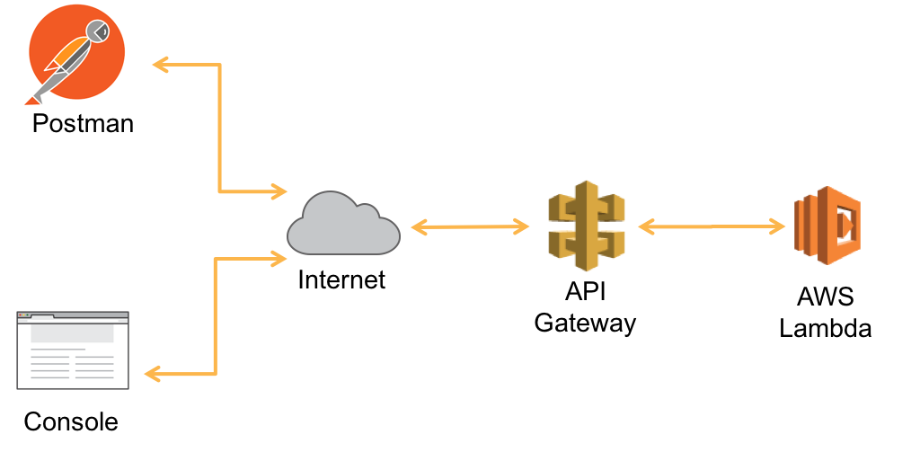

Figure 1: Lab Architecture

Amazon API Gateway is a fully managed service that makes it easy for developers to create, publish, maintain, monitor, and secure APIs at any scale. API Gateway acts as a “front door” for applications to access data, business logic, or functionality from your back-end services, such as workloads running on Amazon Elastic Compute Cloud (Amazon EC2), code running on AWS Lambda, or any Web application.

In this lab, you will create an API that invokes a lambda function to calculate the price of a house (price per square foot). You will deploy a pre-defined sample lambda function and create the back-end API. You will test your APIs using either the API Gateway console and command line tools.

# Lab Pre-Requisites

Before we get started creating our first API Gateway, we need to provision the lambda that the gateway will use. We will use CloudFormation to quickly bootstrap the environment.

1. Click [this deep link](https://console.aws.amazon.com/cloudformation/home?region=us-east-1#/stacks/create/template?templateURL=https://s3.amazonaws.com/serversless-immersion-api-gateway/packaged-template.yaml) to load our CloudFormation Template
2. Once the page loads, click Next.
3. Give the stack a name of “serverless-immersion-day” then click Next.
4. Leave all stack options as default and then click Next.
5. Finally on the review page, select all check boxes under the blue “Capabilities and Transforms”. Then click Create Stack.
6. Continue onto the next step while your stack provisions.

# Lab: Creating Your First API

1. Sign into the AWS Management Console and open API Gateway console at <https://console.aws.amazon.com/apigateway>
2. Click Build under “Rest API”
3. Select “**New API**”
4. Under Settings, Enter the following values:

API Name: **calculatePrice**

Description: **Calculates the price of a house per square meters**

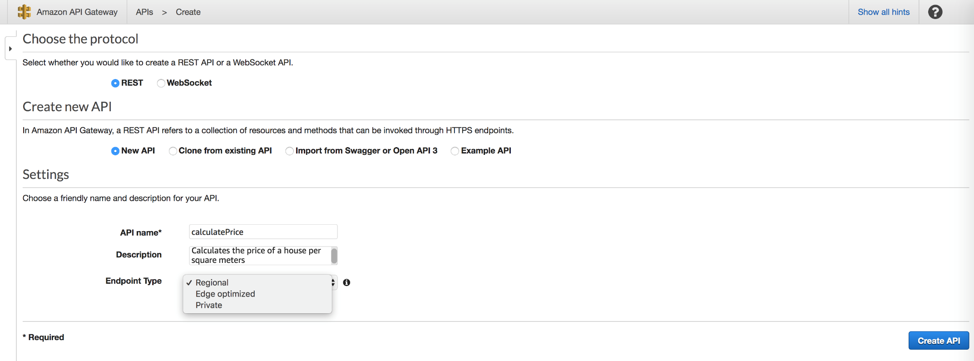

Figure 3: Creating a new API

1. Click “**Create API”**
2. Under *Actions*, choose **“Create Resource”**

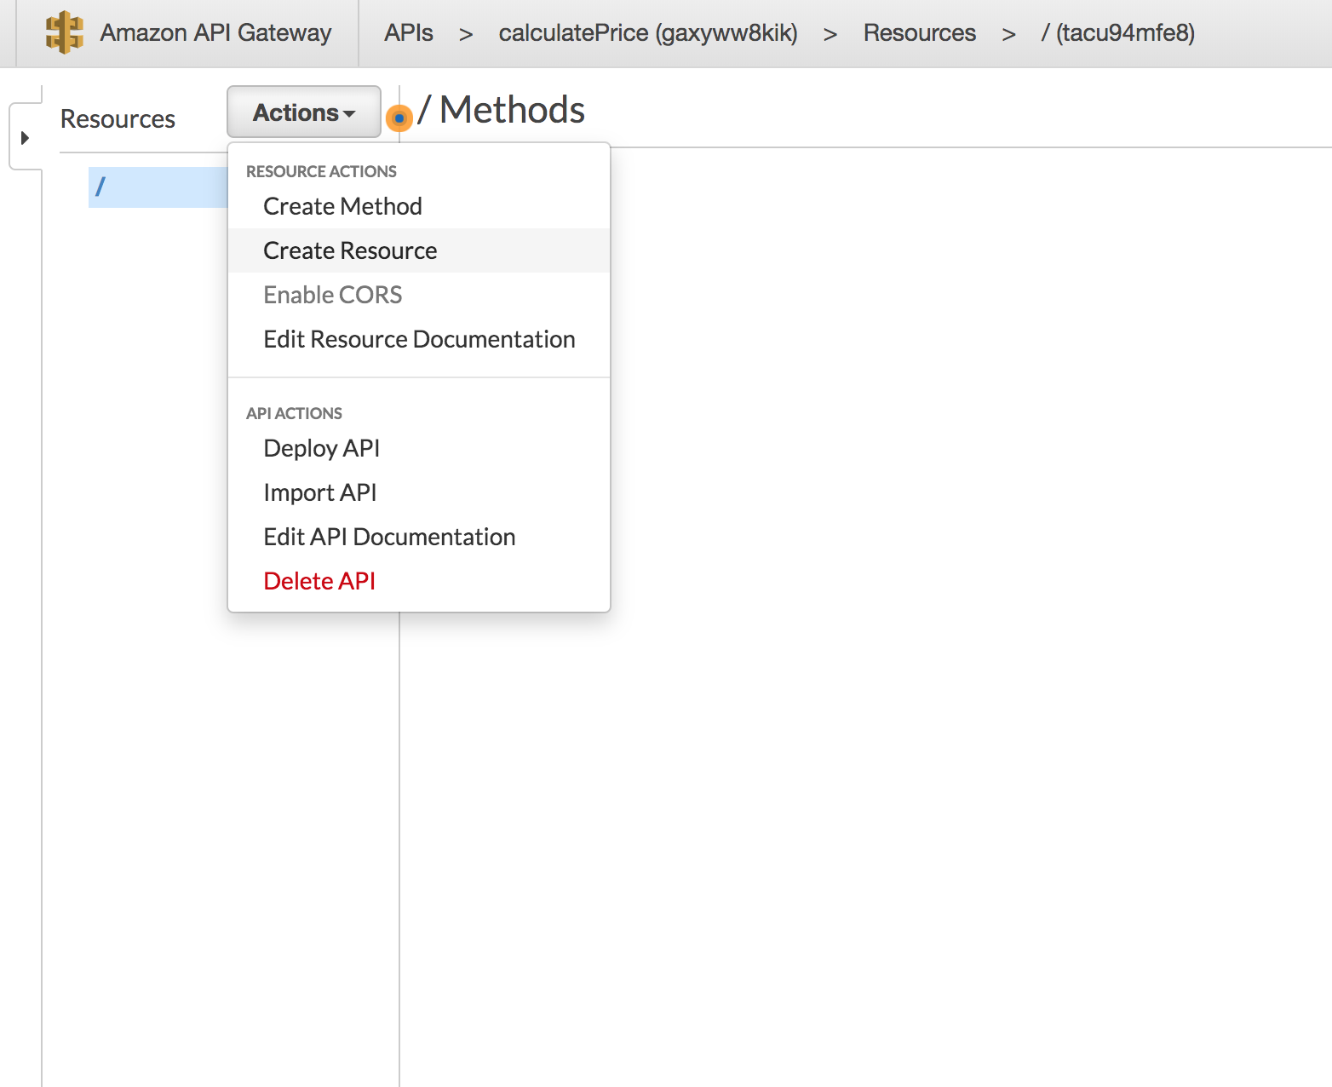

Figure 4: Creating a new resource

1. Enter the following values:

Resource Name: **pricePerMeter**

Resource Path: **pricePerMeter**

1. Click “**Create Resource”**

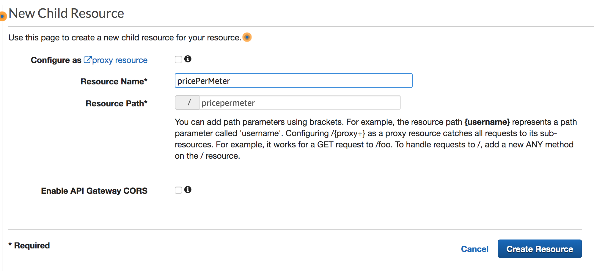

Figure 5: Resource Name and path

1. Select *Actions,* choose **“Create Method”**

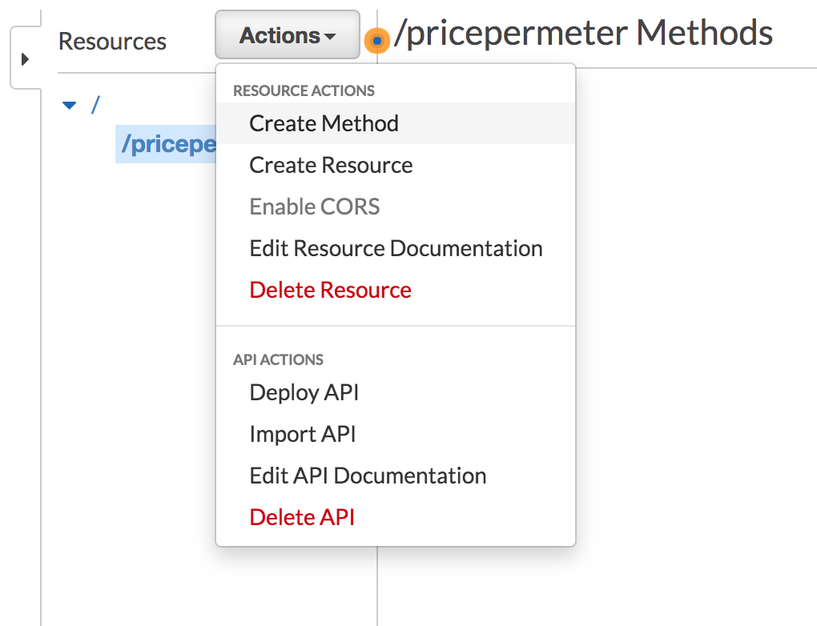

Figure 6: Creating a method

1. Choose “**Post”** and Click on ***check*** *icon* to confirm.
2. Under the *Post* method, Choose the following values:

Integration Type: **Lambda Integration**

Lambda Region: **us-east-1**

Lambda Function: **serverless-immersion-day-stac-CalculateCostPerUnit-XX**

1. Click **Save**.

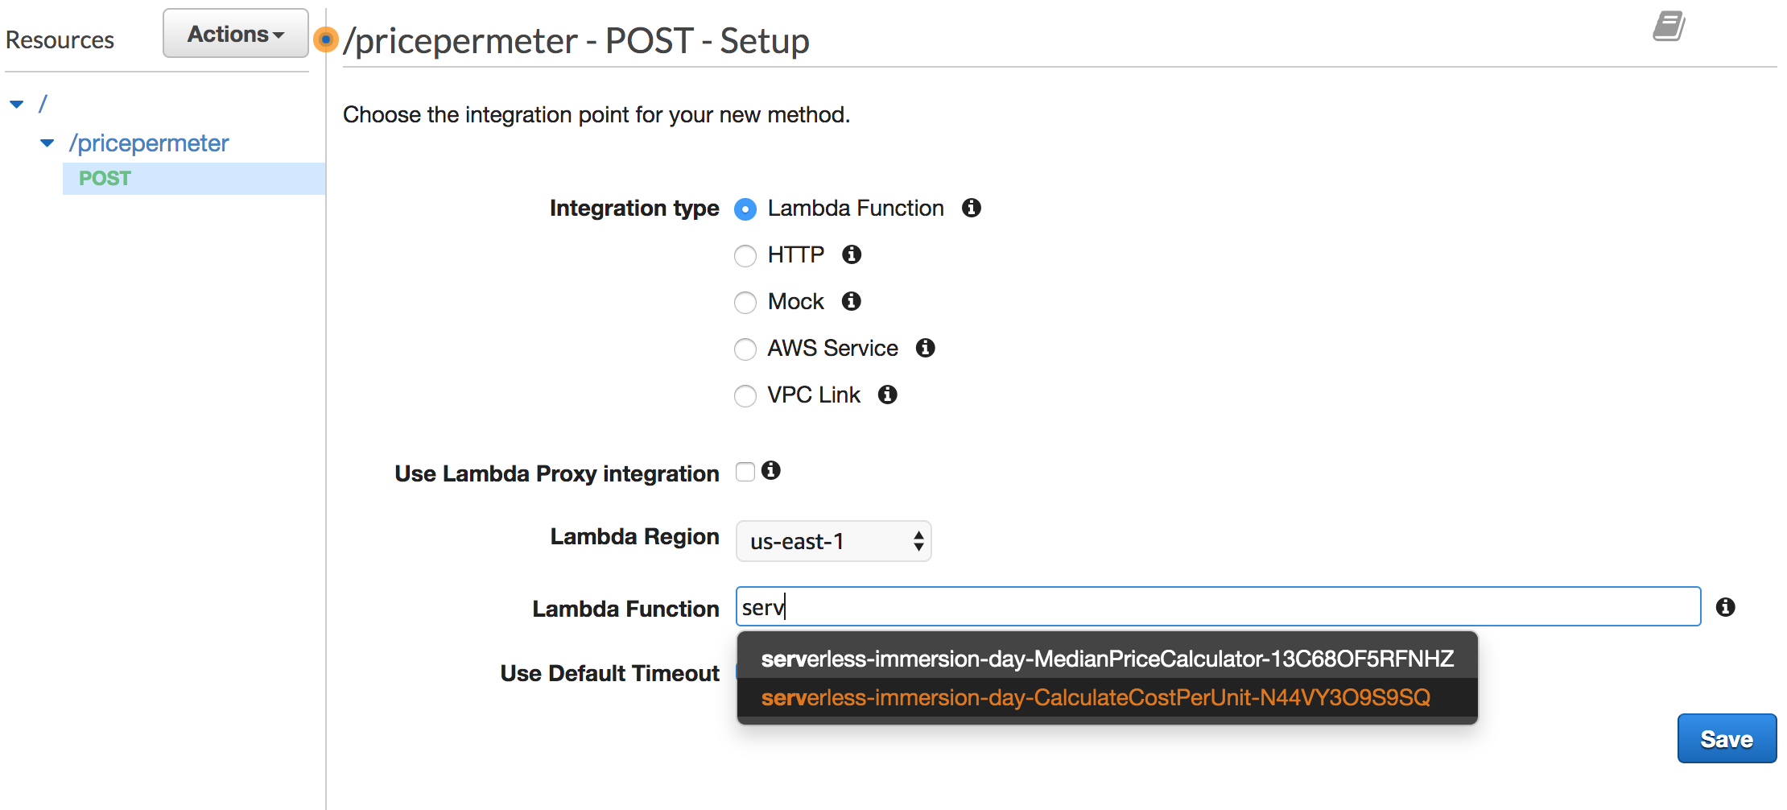

Figure 7: Configuring POST action

1. In the dialogue box, “Add Permission to Lambda Function”, Click “**OK”**.

You have now configured your API to call the “costCalculator” lambda function. The API Gateway pane shows the request and response flow of data.

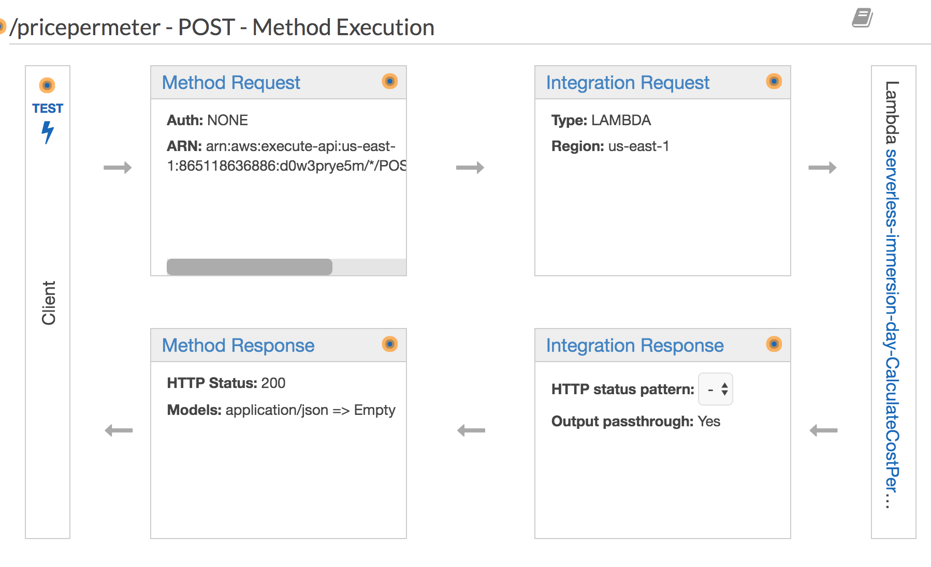

Figure 8: API Gateway console pane

1. Click on the “**Test”** icon to provide a sample request message.
2. Copy and Past the following JSON Sample in the “**Request Body”** section

{

"price": "400000",

"size": "1600",

"unit": "sqFt",

"downPayment": "20"

}

1. Click “**Test”**

Please note the Response Body with a “status code” of 200. The body of the response contains the price per unit and the total cost. The header of the response along with the message body is composed by the lambda function. The testing page also shows a complete request/response log.

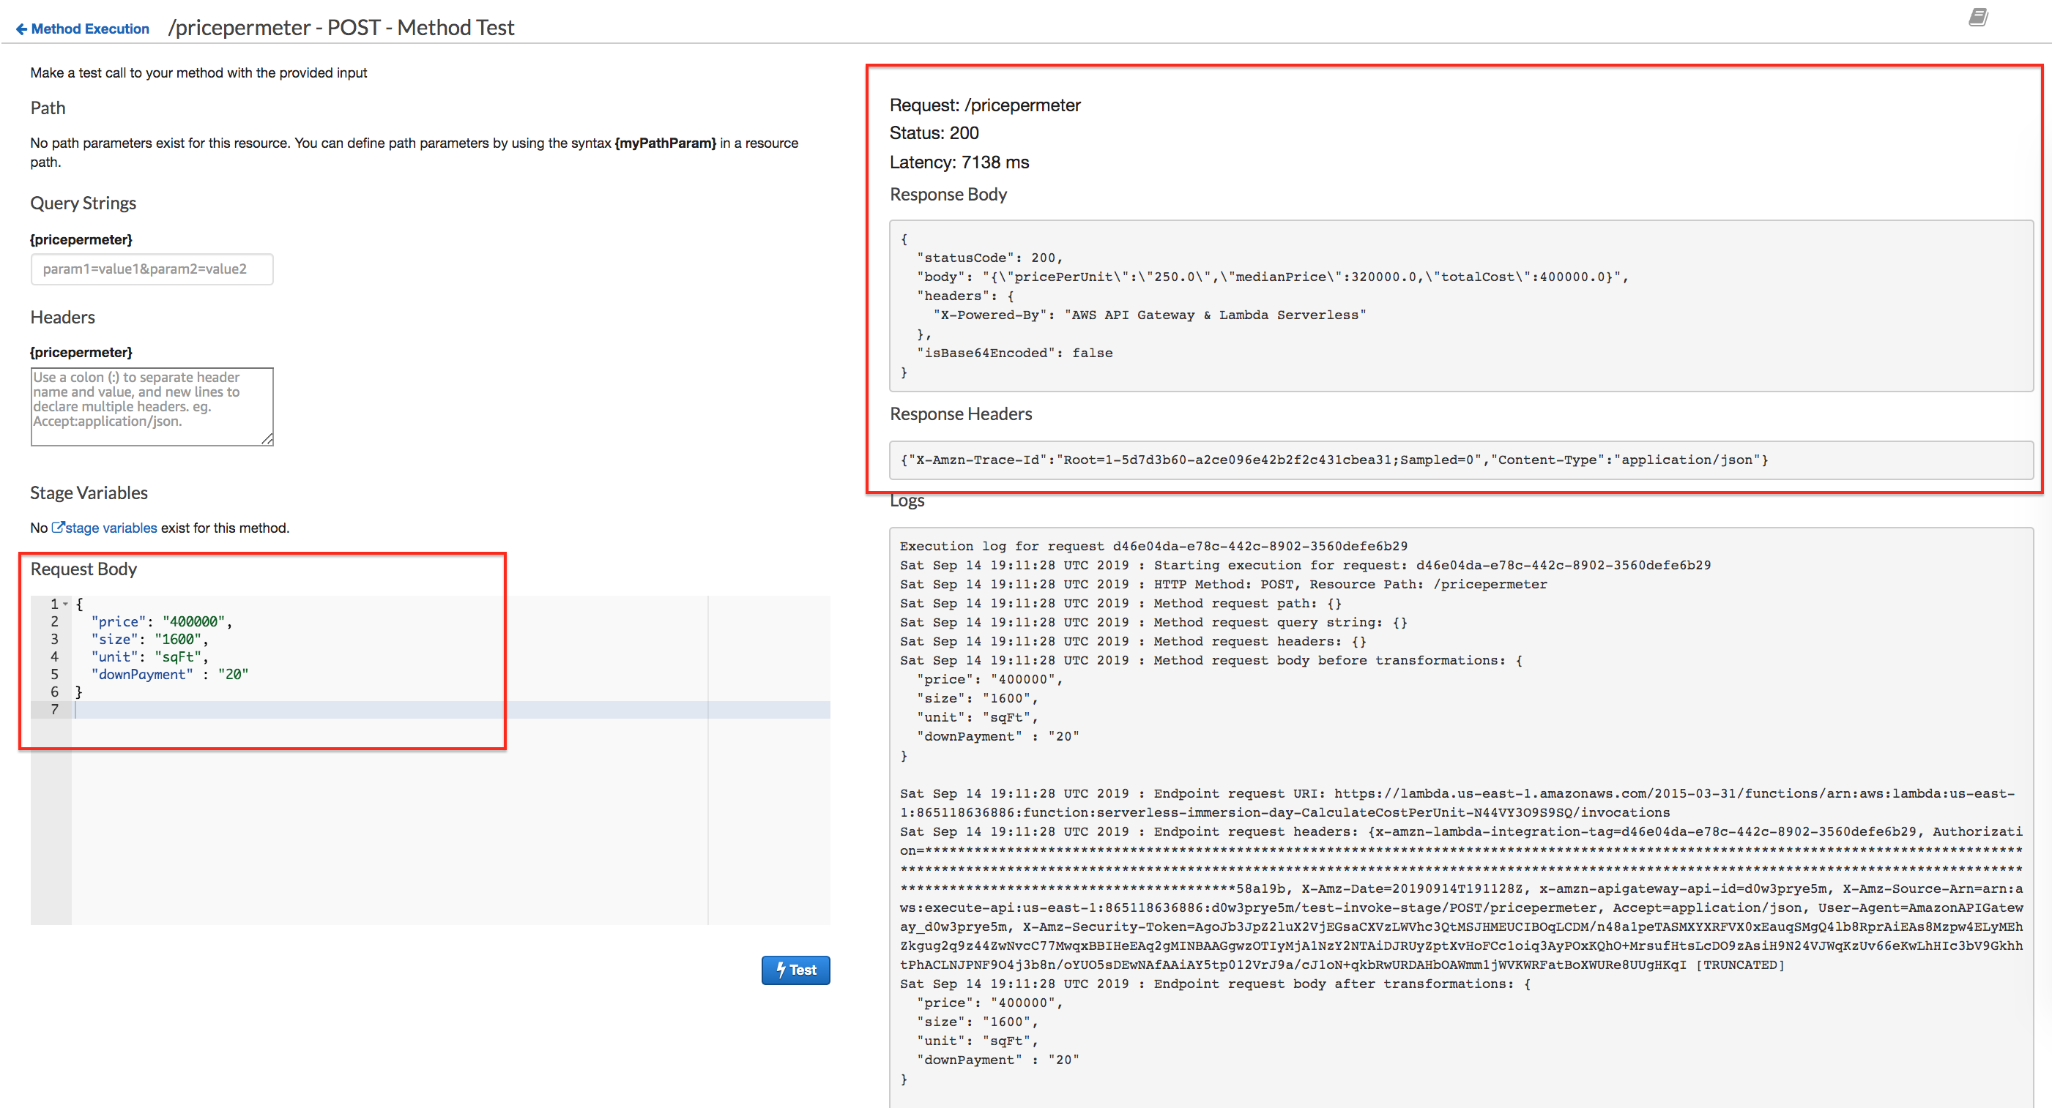

Figure 9: Testing API

Notice that the lambda service returned the total cost, but did not account for the down payment. In the next section, we will transform the message to pass the down payment amount to the lambda function.

## Message Transformation

In API Gateway, a mapping template is used to transform data from one format to another. A JSON path expressions can be used to map and transform the integration payload to any desired format. In addition, a model (schema) can be created to define the structure of a message payload. Having a model also enables you to generate an SDK that can be used by the client application to send properly formatted messages.

In this section, you will first create a model to represent the schema of the incoming request and response messages. Then you will validate and transform the incoming request message to match the downstream service (lambda) specification. The returned response message will also be formatted to properly capture the unit metrics.

### Building a Model

1. In the box that contains the name of the API (calculatePrice), select **Models**.

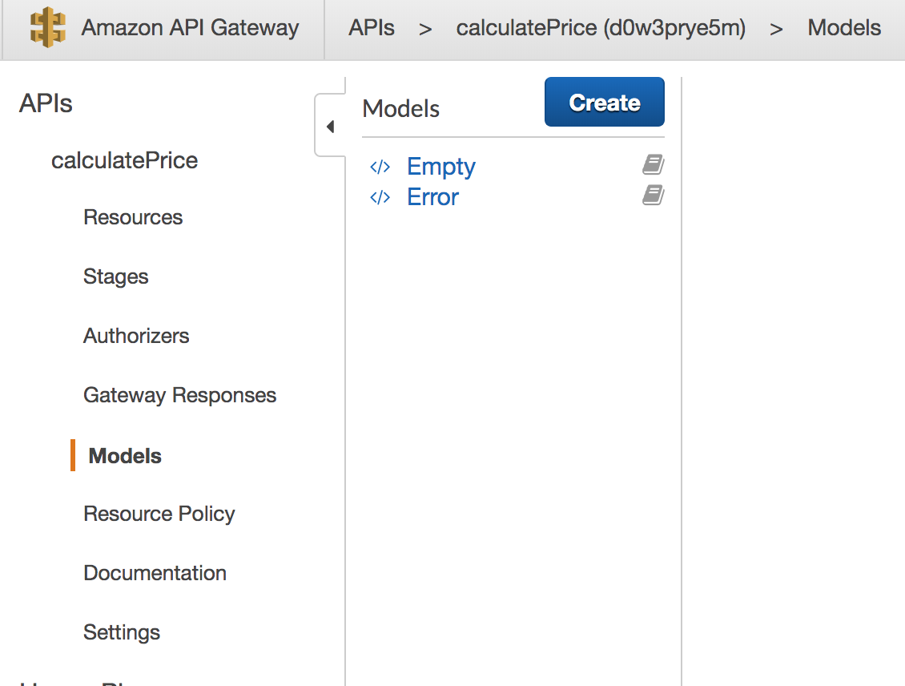

Figure 10: Create a new Model

1. Click “**Create”**.
2. Enter the following information:

Model name: **costCalculatorRequest**

ContentType: **application/json**

Model Description: **CostCalculator incoming request schema**

Model Schema: Copy and Paste the following:

{

"$schema": "http://json-schema.org/draft-04/schema#",

"title": "costCalculatorRequestModel",

"type": "object",

"properties": {

"price": { "type": "number" },

"size": { "type": "number" },

"unit": { "type": "string"},

"downPayment": { "type": "number"}

}

}

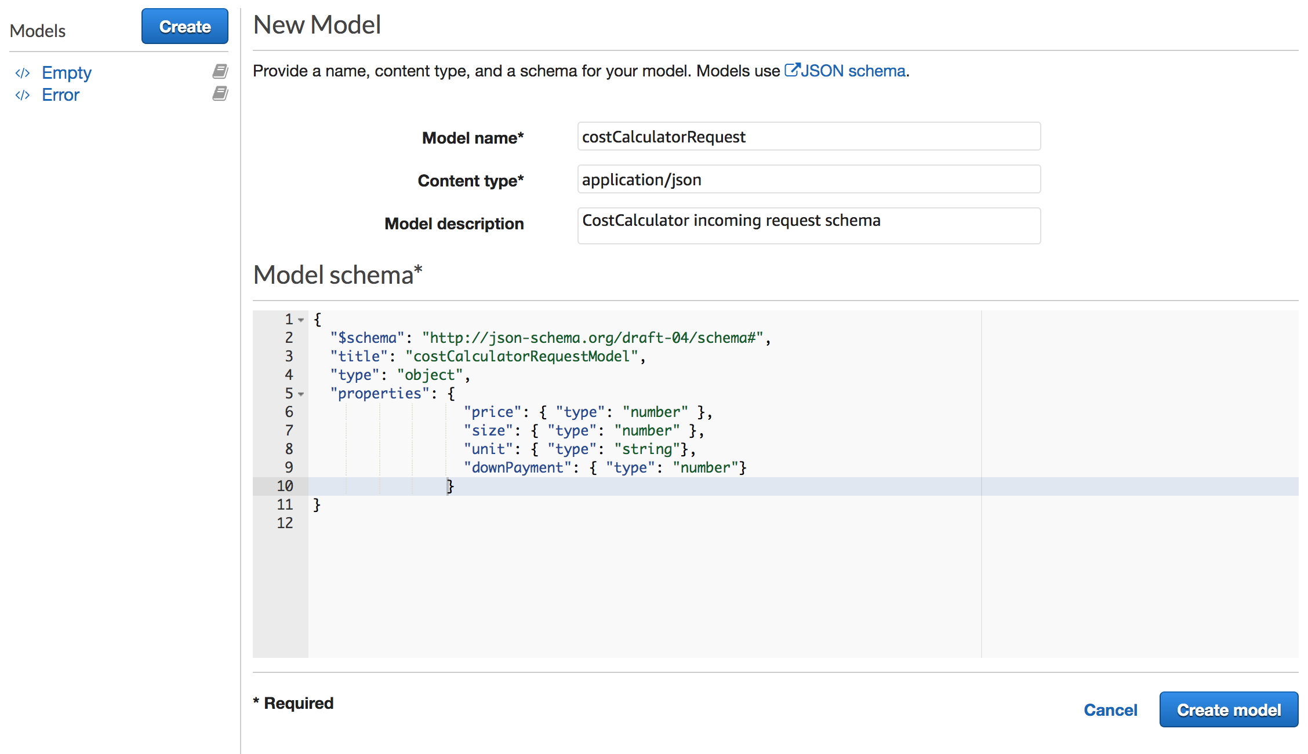

Figure 11: Model definition

1. Click **Create model.**

Now that the models are created, the next step is to transform the incoming request and response messages.

### Transform Request Payload

1. Go back to the “**CalculatePrice”** API and click on the “**POST”** action.
2. From the Gateway pane, click on “**Integration Request”**



Figure 12: Integration Request

1. From the Integration Request pane, expand the “**Mapping Templates”**
2. Select “**When there are no templates defined (recommended**)”
3. Click on “**Add mapping template”**
4. Type **“application/json”** for the Content-Type. Select “**check”** mark.
5. Under the “***Generate Template”***, select “**CostCalculatorRequest”** model
6. Update the template as follows:

#set($inputRoot = $input.path("$"))

{

"price": "$inputRoot.price",

"size": "$inputRoot.size",

"unit": "$inputRoot.unit",

"downPaymentAmount": "$inputRoot.downPayment"

}

1. Click **Save**

The first statement #set($inputRoot = $input.path(“$”)) uses a JSONPath expression and returns an object representation of the result. This allows you to access and manipulate elements of the payload natively in [Apache Velocity Template Language (VTL)](http://velocity.apache.org/engine/devel/vtl-reference-guide.html).

After the “inputRoot” variable is assigned to the root of the request, we can map the value of price, size and unit into the appropriate fields. **Notice that the last statement is mapping the value of “downPayment to a new attribute called “downPaymentAmount”**. The downstream lambda function uses the downPaymentAmount to calculate the total price. (i.e. totalPrice = price + downPaymentAmount).

The next step is to map the integration response. An API Gateway response is identified by a response type defined by API Gateway. The response consists of an HTTP status code, a set of additional headers that are specified by parameter mappings, and a payload that is generated by a non-VTL mapping template

Similar to the request mapping, create the mapping template for the response payload. Perform the following:

1. Go back to the “**CalculatePrice”** API and click on the “**POST”** action.
2. From the API Gateway pane, select “**Integration Response”.**
3. Click on “**Integration Response”**

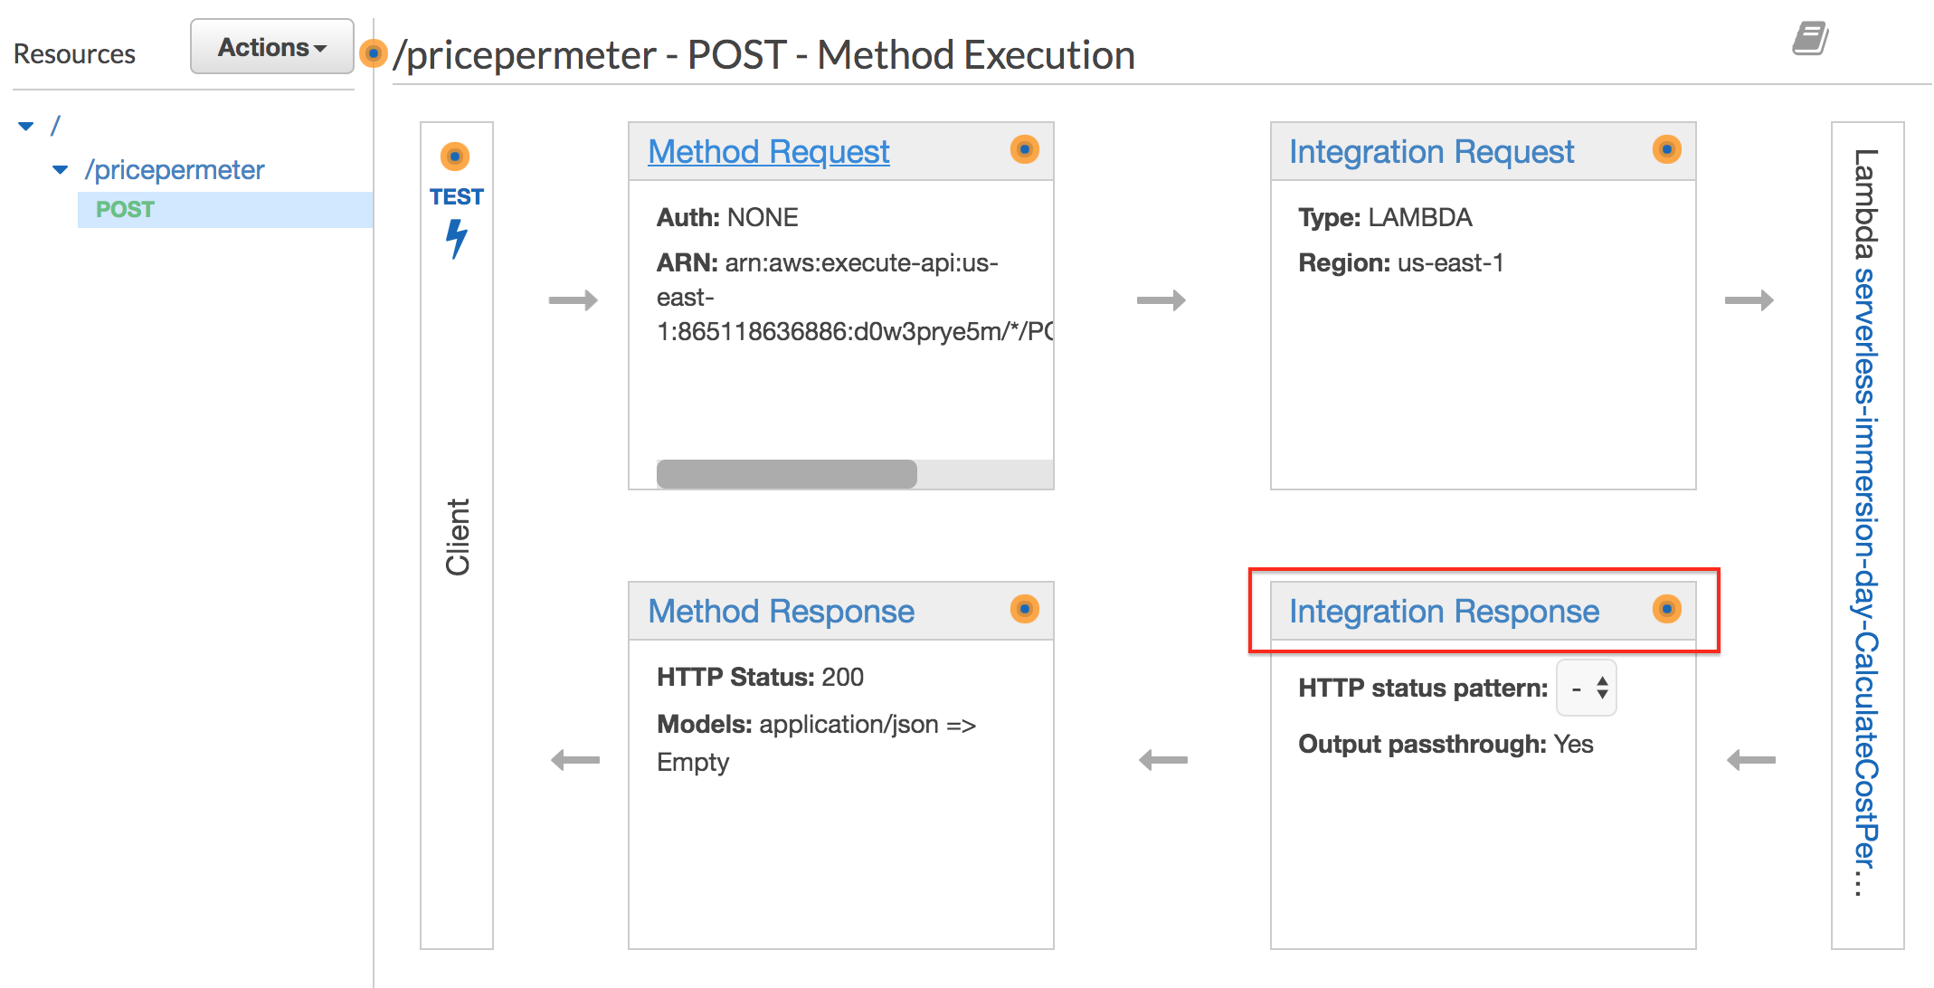

Figure 13: Integration Response

1. **Expand** the 200 Method response row
2. Expand the “**Mapping Templates”**
3. Click on “**application/json**” Content-Type
4. Choose “**“Method Request Passthrough**”
5. Click **Save**



Figure 14: Method Request - Passthrough

In the response mapping, we have chosen to pass through the response content from lambda without making any further modifications. The “method request passthrough” is a pre-defined template that maps the request header, body, parameters and context. The $context variable holds all the contextual information of your API call.

1. Go back to your “calculatePrice” API and click on the “POST” method to test your API.
2. Click on the “**Test”** icon to provide a sample request message.
3. Copy and Past the following JSON Sample in the “**Request Body”** section

{

"price": "400000",

"size": "1600",

"unit": "sqFt",

"downPayment": "20"

}

1. Click on “**Test”**

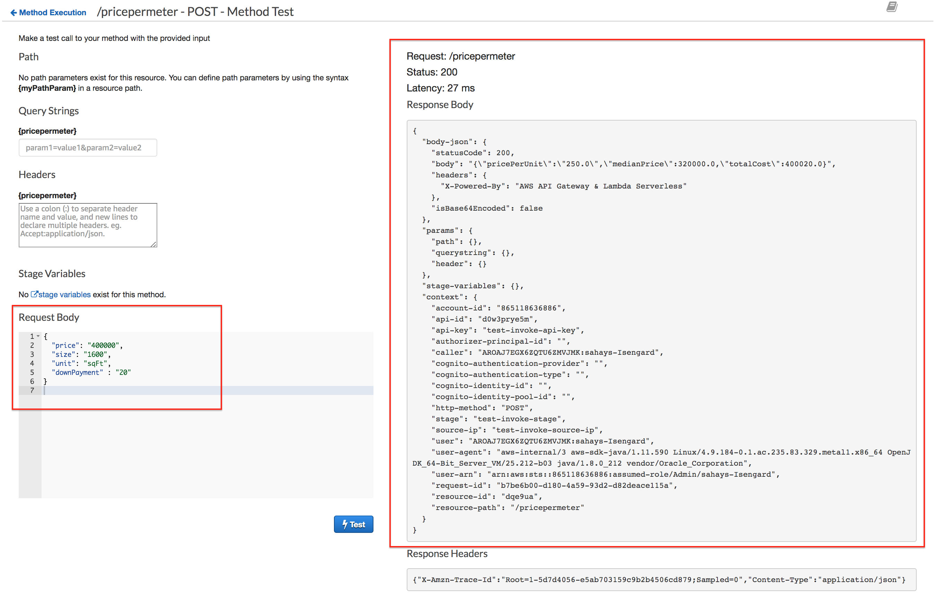

Figure 15: Message Response

Notice that the “downPayment” amount was added to the price. The response also contains the header and context attributes.

## Request Validation

Request validation is used to ensure that the incoming request message is properly formatted and contains the proper attributes. You can set up request validators in an API’s Swagger definition file and then import the Swagger definitions into API Gateway. You can also set them up in the API Gateway console or by calling the API Gateway REST API, AWS CLI, or one of the AWS SDKs.

The API Gateway console lets you set up the basic request validation on a method using one of the three validators:

* **Validate body**: This is the body-only validator.
* **Validate query string parameters and headers**: This is the parameters-only validator.
* **Validate body, query string parameters, and headers**: This validator is for both body and parameters validation.

In this section, we will use the console to setup request validation and validate only the body.

1. Select “**CalculatePrice”** API and choose the “POST” method.
2. Choose **Method Request**.

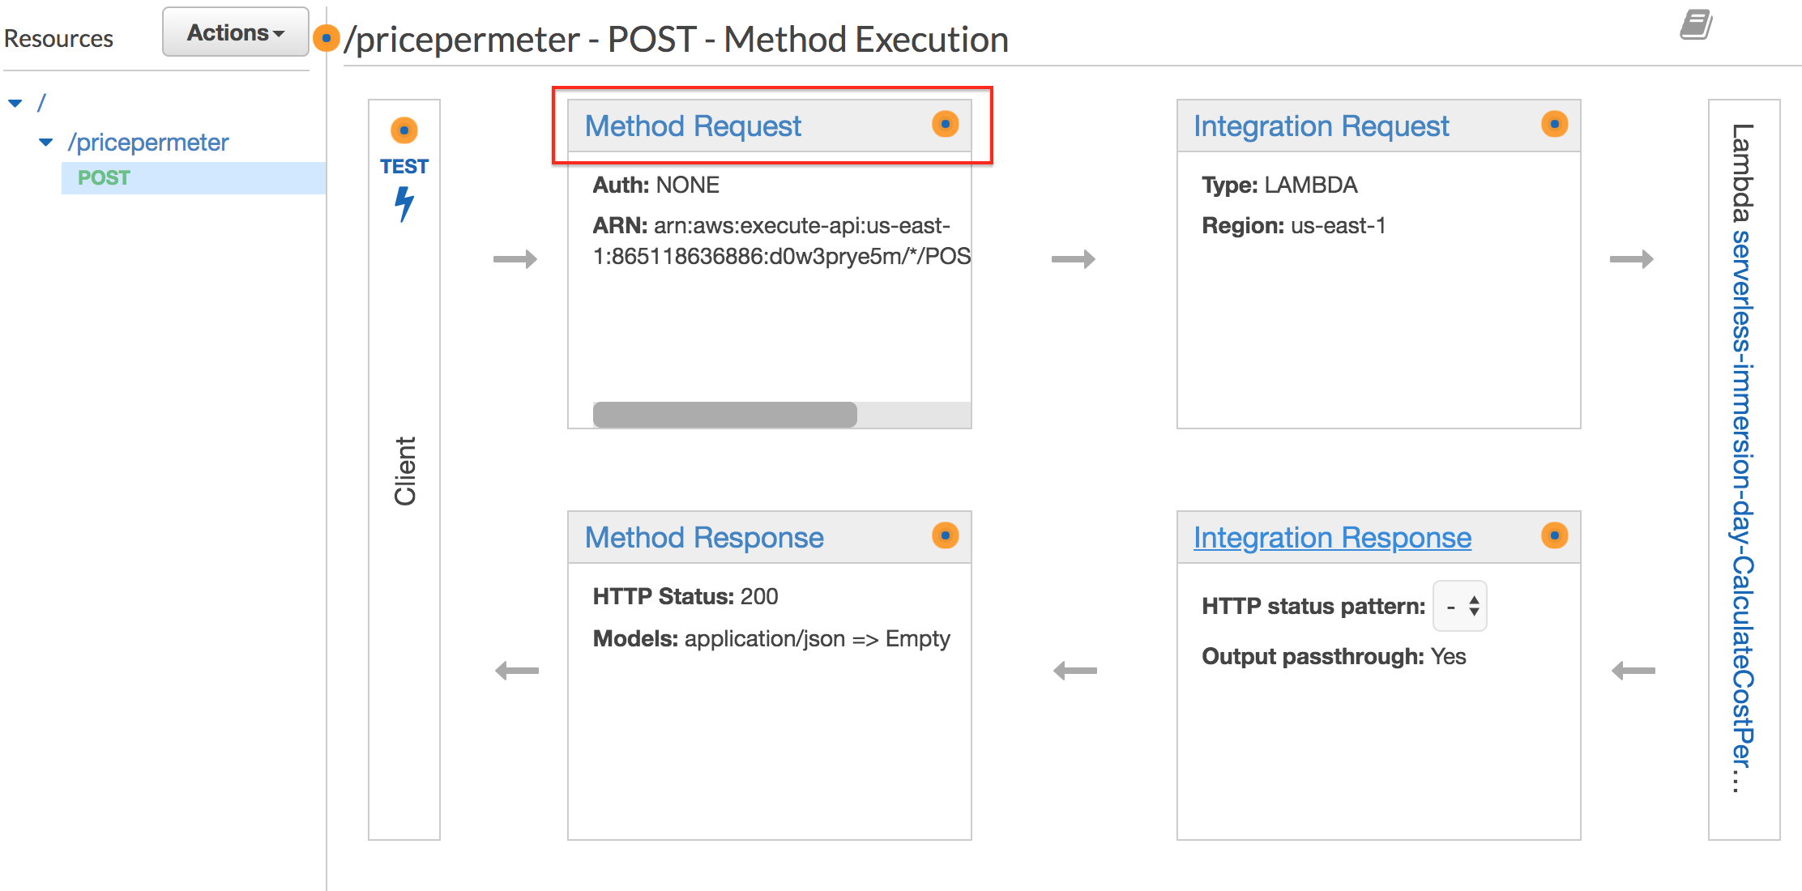

Figure 16: Method Request

1. Choose the pencil icon of **Request Validator** under **Settings**.
2. Choose **Validate body** from the **Request Validator** drop-down list and then click the check mark icon to save your choice.

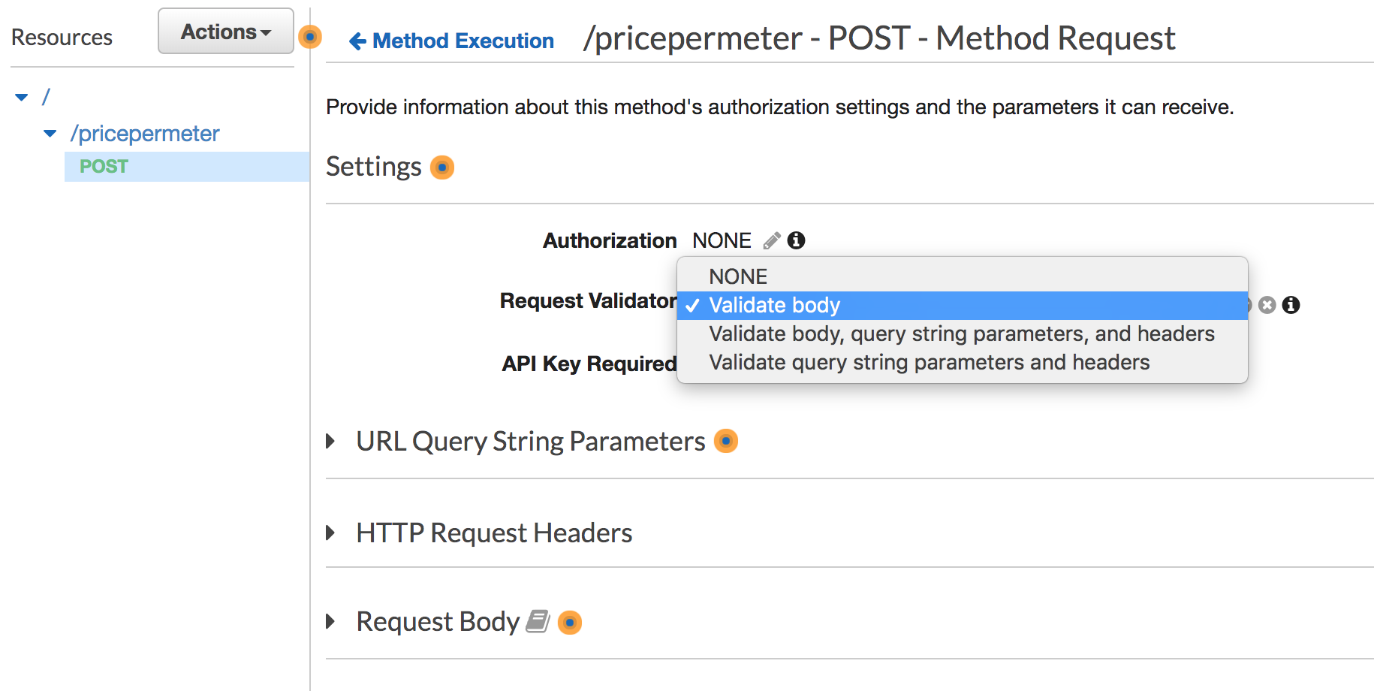

Figure 17: Message Validation

1. Expand **“Request Body”**
2. Click **“Add model”**
3. Enter “**application/json”** for Content Type
4. Choose “**costCalculatorRequest**” for the model name
5. Click the “**check**” icon to confirm.

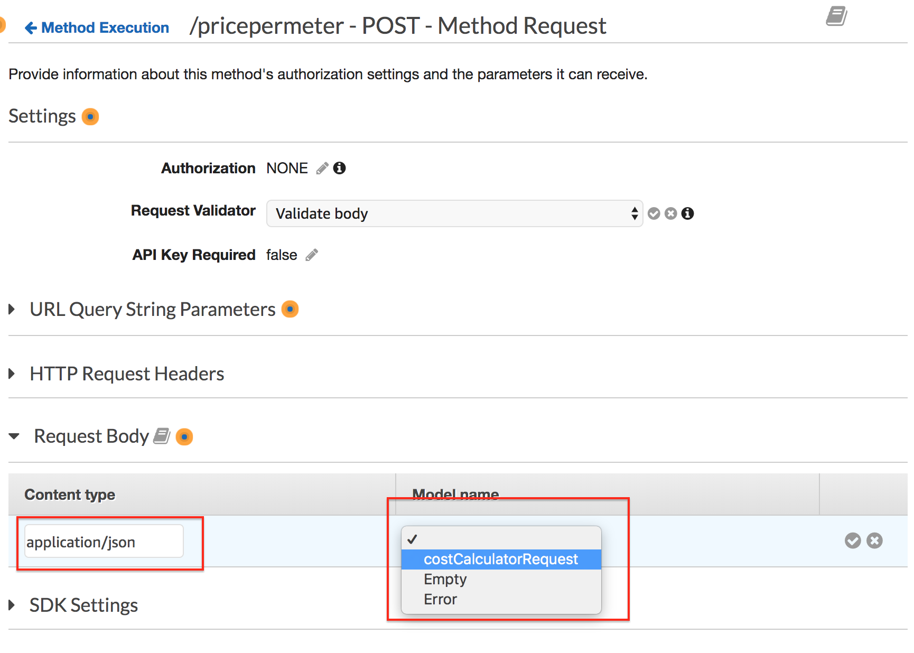

Figure 18: Request validation

Go back to the API Gateway console and select the “POST” integration method to test out the API.

1. Click on the “**Test”** icon to provide a sample request message.
2. Copy and Past the following JSON Sample in the “**Request Body”** section

{

"price": "400000",

"size": "1600",

"unit": "sqFt",

"downPayment": "20"

}

1. Click on “**Test”**

Notice that this time, the message failed with a message of “**Invalid request body**”.

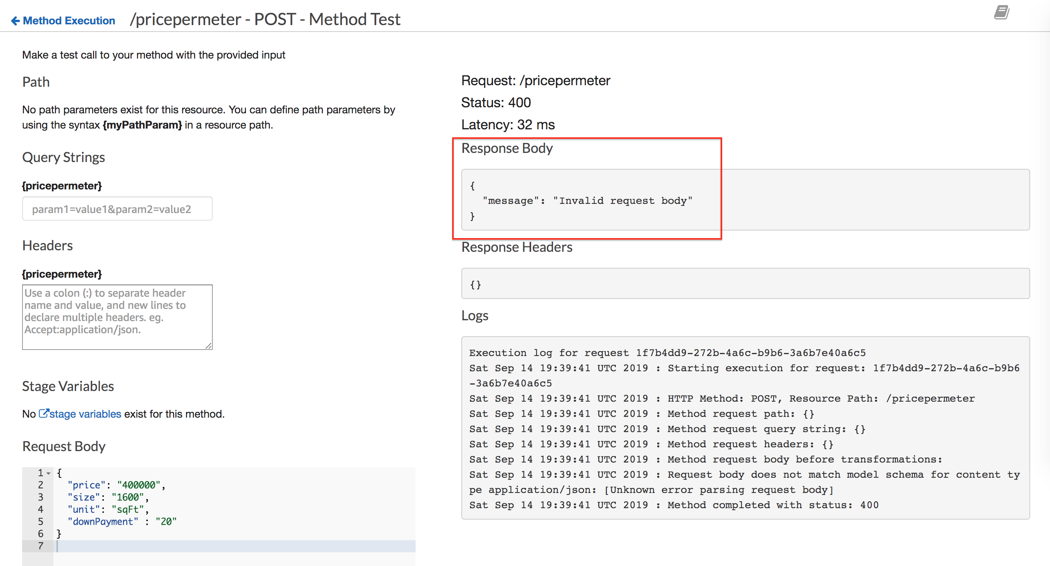

Figure 19: Failed Validation Response

The request failed validation because price, size and downPayment are defined as “number” in our model/schema. Hence, remove the string quotes (“ ”) from price, size, and downPayment and try your request again.

1. Click on the “**Test”** icon to provide a sample request message.
2. Copy and Past the following JSON Sample in the “**Request Body”** section

{

"price": 400000,

"size": 1600,

"unit": "sqFt",

"downPayment": 20

}

1. Click on “**Test”**

You should see that the normal response is returned by the service.

## API Deployment

At this point, we have been testing our API using the API Gateway console. Now that we have made the necessary configuration for authorization, we are ready to deploy our API.

1. Select **POST method** from the API Gateway console for the “calculatePrice” API
2. Select “**Action”** then choose “**Deploy API”**

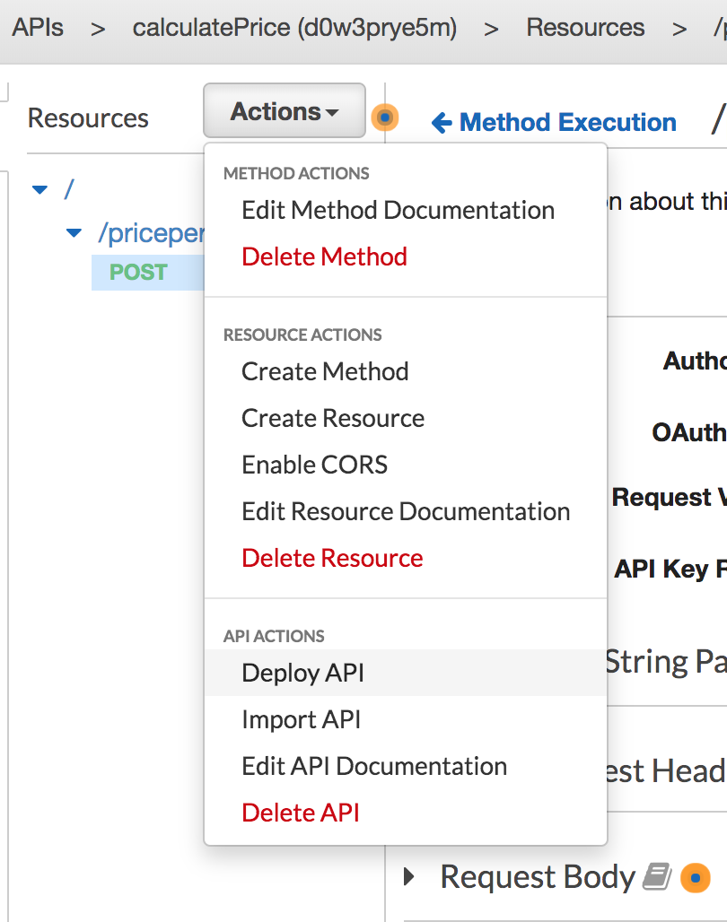

Figure 31 : Deploy API

1. Create a new Stage. Enter the following values:

Stage Name: dev

Stage description: development stage for calculate price API

Deployment

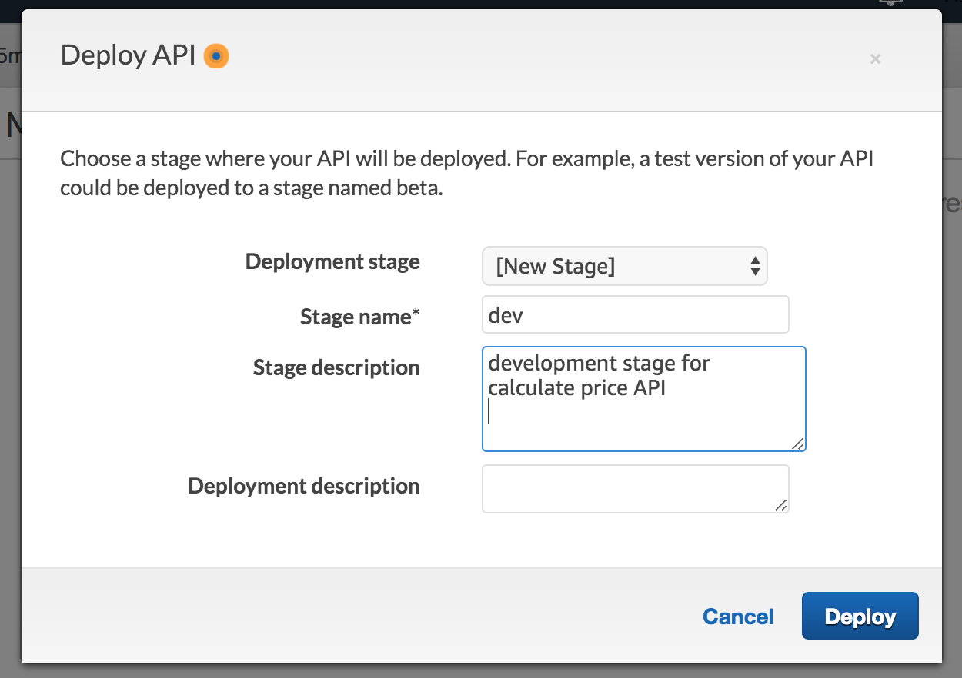

Figure 32 : Deploy dev stage

1. Click **“Deploy”**
2. Expand the “dev” stage, and click on the “POST” method of the pricepermeter.

**Note the API/Invoke URL. Copy this value as it will be used in the subsequent steps.**

Up to this point, we have used the local API Gateway console to test our API. Now that we have deployed the API, we can test it using external tools. For this lab, we will use command line tools, but any rest client with work.

For users on macOS or Linux, we run the below curl command. Be sure to replace the URL with the URL from the console.

curl -X 'POST' https://{URL_FROM_CONSOLE_HERE}/dev/pricepermeter \

--data '{"price":400000,"size":1600,"unit":"sqFt","downPayment":20}' \

--header "Content-Type: application/json"

For example (Not this API will not be active by the time of lab. Please replace with your URL.

curl -X 'POST' [https://vp5pozkz94.execute-api.us-east-1.amazonaws.com/dev/pricepermeter \](https://vp5pozkz94.execute-api.us-east-1.amazonaws.com/dev/pricepermeter%20\)

--data '{"price":400000,"size":1600,"unit":"sqFt","downPayment":20}' \

--header "Content-Type: application/json"

For users on Windows. Open a new PowerShell Window and run the below command. Be sure to replace the URL with the URL from the console.

Invoke-WebRequest -Method Post `

-Headers @{"Content-Type"= " application/json"} `

-Body '{"price":400000,"size":1600,"unit":"sqFt","downPayment":20}' `

-Uri https:// {URL_FROM_CONSOLE_HERE}//dev/pricepermeter

For example (Not this API will not be active by the time of lab. Please replace with your URL.

Invoke-WebRequest -Method Post `

-Headers @{"Content-Type"= " application/json"} `

-Body '{"price":400000,"size":1600,"unit":"sqFt","downPayment":20}' `

-Uri https://vp5pozkz94.execute-api.us-east-1.amazonaws.com/dev/pricepermeter

**Congratulations**, you have just deployed your first API

## Lab Summary

In lab 1, you created your first API using AWS API Gateway. In this lab, you configured API Gateway to call a lambda service, transformed and validated the request message, and deployed the API.